**HOW TO DEBUG A SERVERLESS APP LOCALLY**

In this project, we will use the AWS Cloud9 IDE to create a function in AWS Lambda and an accompanying API in Amazon API Gateway. After you create the function and its API, you run and debug them locally. Then you run the function and API in Lambda and API Gateway in production.

**Steps:**

* [Step 1: Create and Open the Environment](https://docs.aws.amazon.com/cloud9/latest/user-guide/tutorial-lambda-create-environment.html)
* [Step 2: Create the Lambda Function and API](https://docs.aws.amazon.com/cloud9/latest/user-guide/tutorial-lambda-create-function.html)
* [Step 3: Add Code to the Function](https://docs.aws.amazon.com/cloud9/latest/user-guide/tutorial-lambda-add-code.html)
* [Step 4: Run or Debug the Function Locally](https://docs.aws.amazon.com/cloud9/latest/user-guide/tutorial-lambda-run-or-debug-local-function.html)
* [Step 5: Clean Up](https://docs.aws.amazon.com/cloud9/latest/user-guide/tutorial-lambda-clean-up.html)

[**Step 1: Create and Open the Environment**](https://docs.aws.amazon.com/cloud9/latest/user-guide/tutorial-lambda-create-environment.html)**:**

* For this project I have chosen cloud9 as my IDE environment.
* First we will need to create a cloud9 platform which will give us access to our aws console.

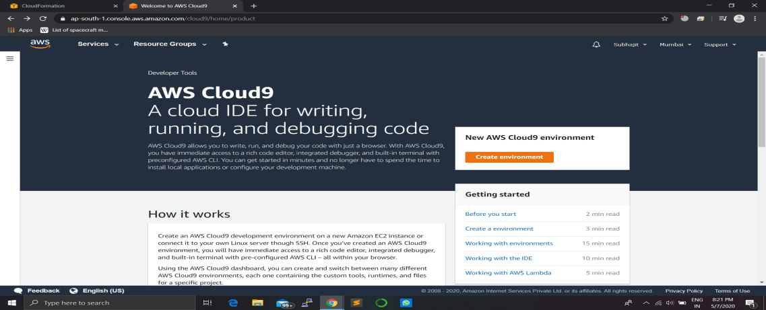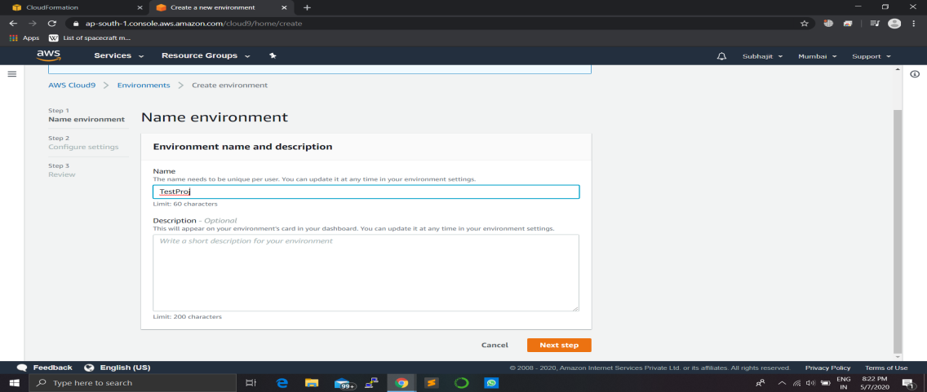

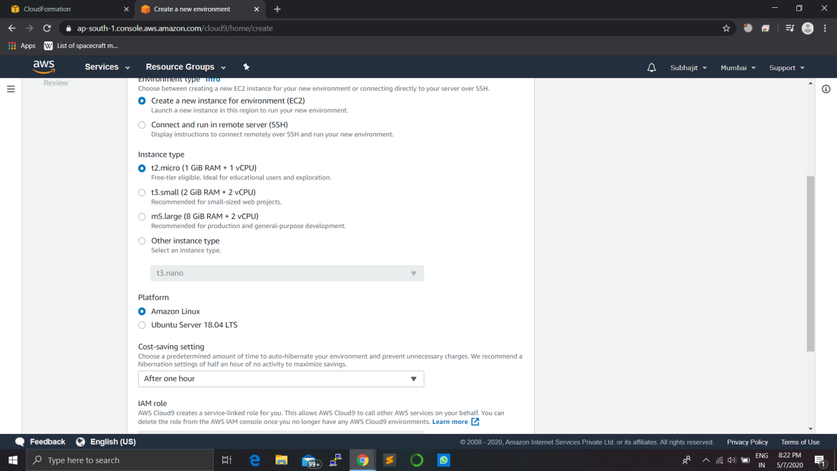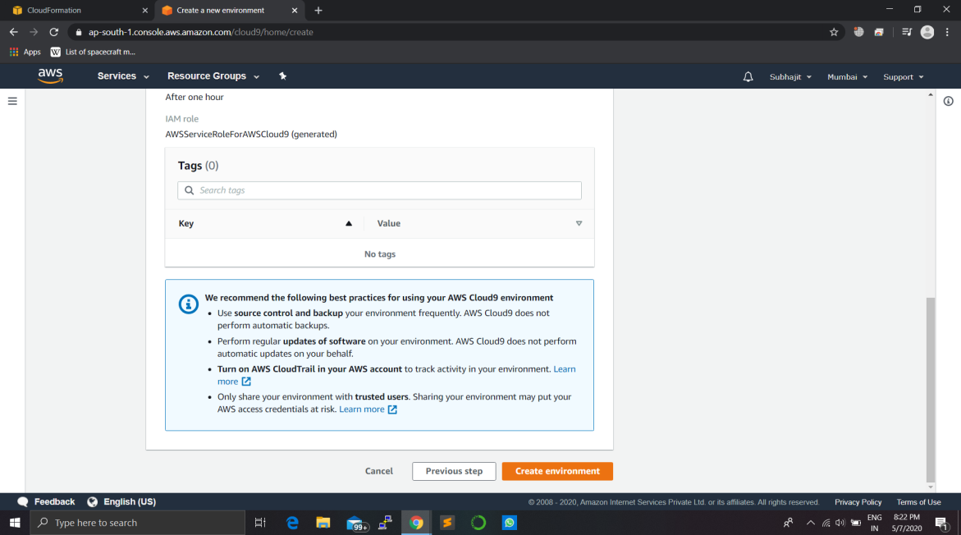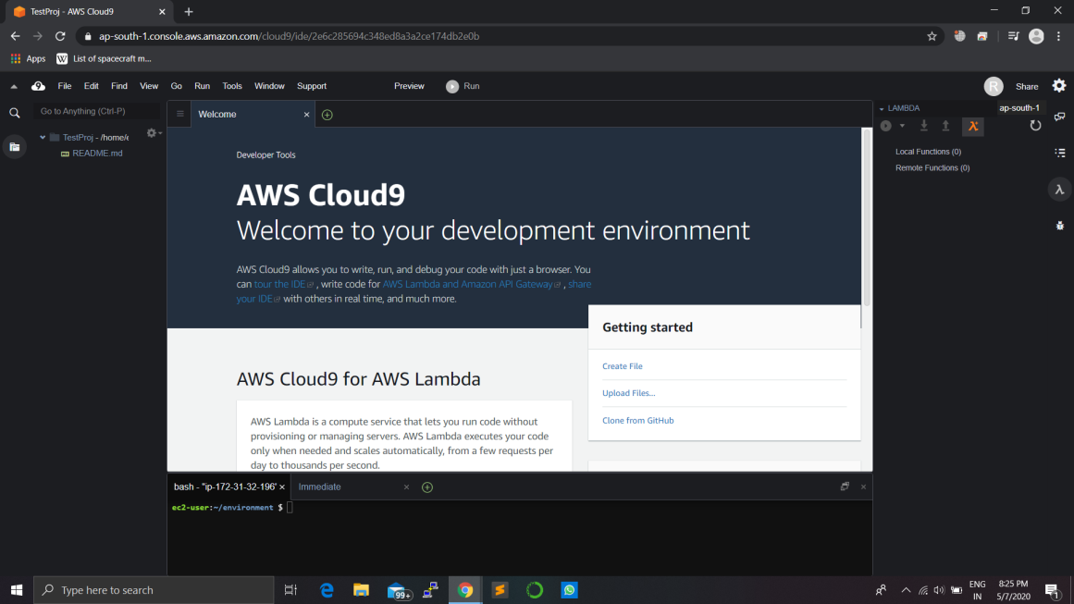

[**Step 2: Create the Lambda Function and API**](https://docs.aws.amazon.com/cloud9/latest/user-guide/tutorial-lambda-create-function.html)**:**

* In this step we will be creating a lambda function and api in order to deploy our code.
* We can also import a lambda function aws directly.

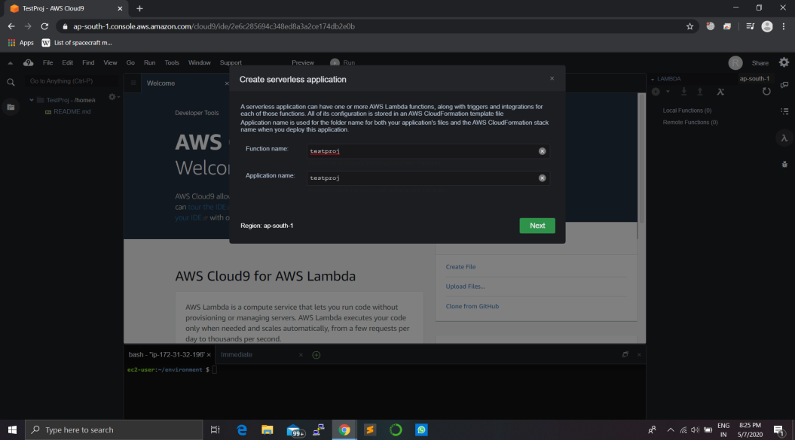

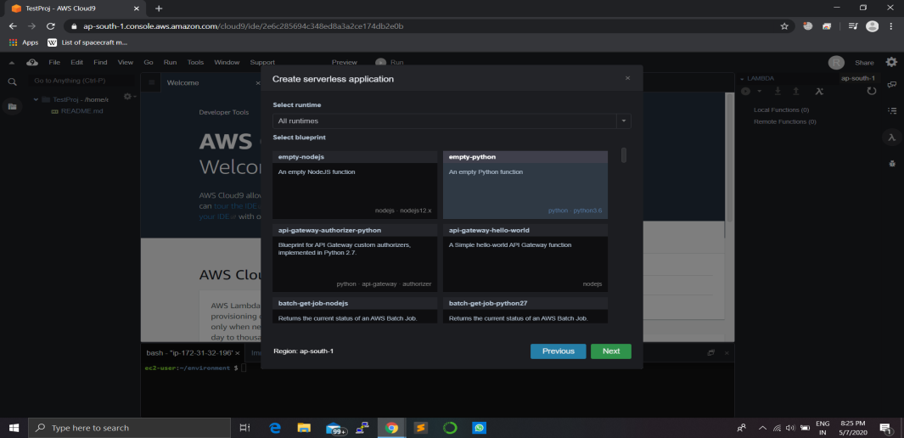

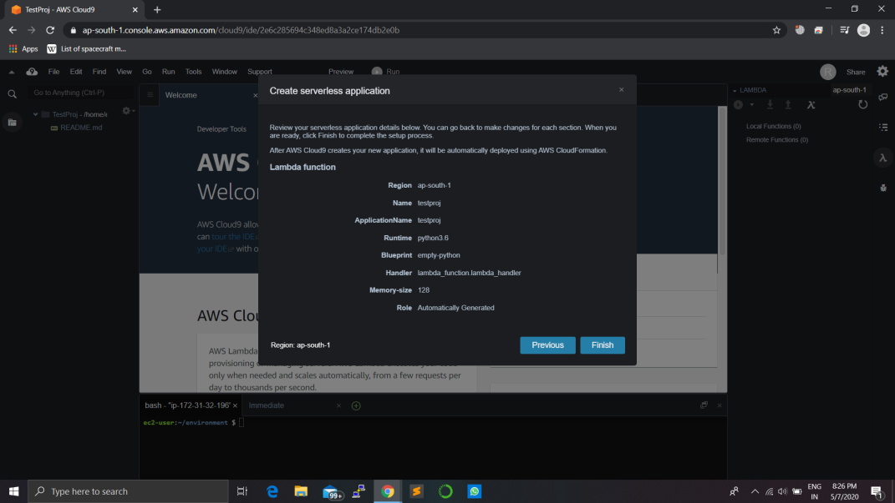

[**Step 3: Add Code to the Function**](https://docs.aws.amazon.com/cloud9/latest/user-guide/tutorial-lambda-add-code.html)**:**

* Here we will either write our own code or we can also upload it locally.
* There are many nos of format you can follow during coding but I have used a python code here.

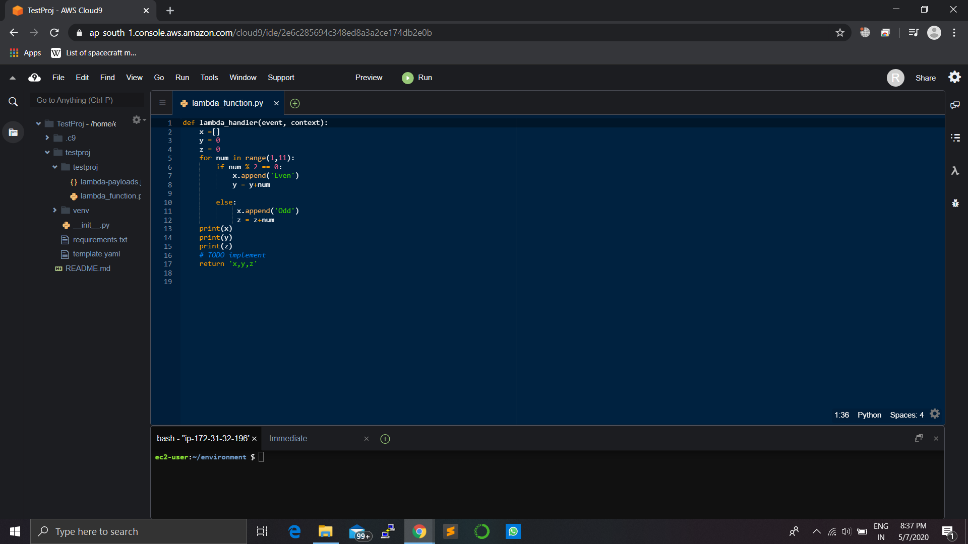

[**Step 4: Run or Debug the Function Locally**](https://docs.aws.amazon.com/cloud9/latest/user-guide/tutorial-lambda-run-or-debug-local-function.html)**:**

* After we have deployed our code we can always test it by debugging it locally.
* We also have the option to debug our api and function remotely but I have gone for local debug here.
* By debugging we can always control the flow of the result and we can also choose the api flow as well.

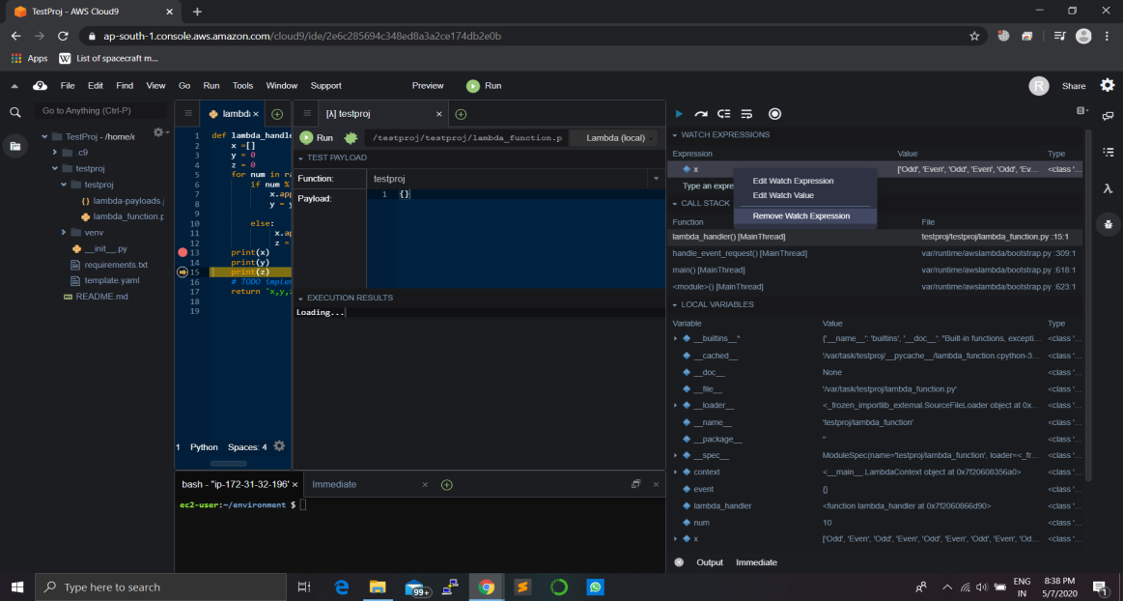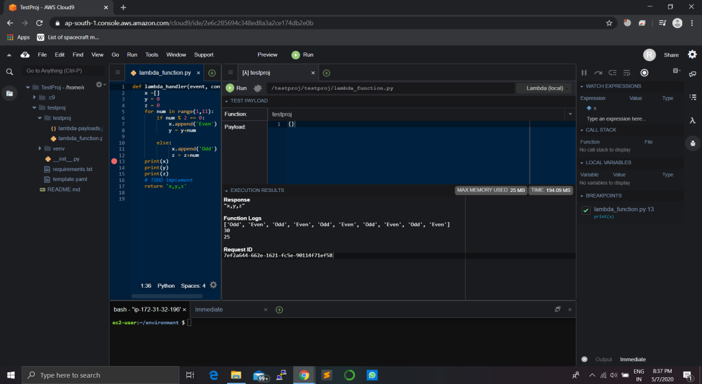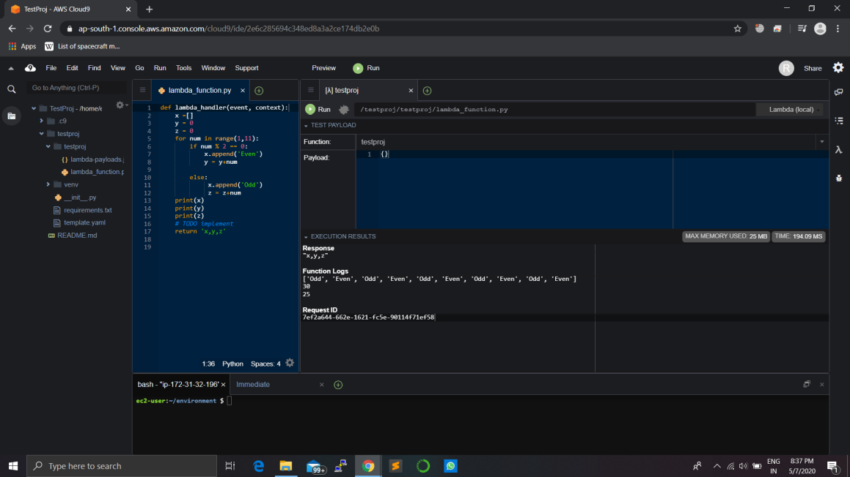

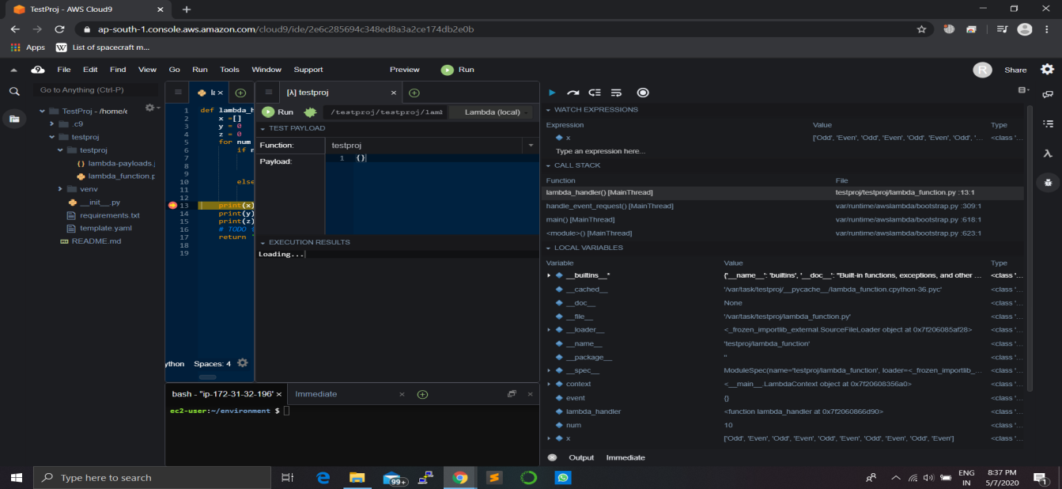

[**Step 5: Clean Up**](https://docs.aws.amazon.com/cloud9/latest/user-guide/tutorial-lambda-clean-up.html)**:**

* Finally we can clean up our project by deleting the above created steps.
* We also have to delete the cloud formation and cloud9.

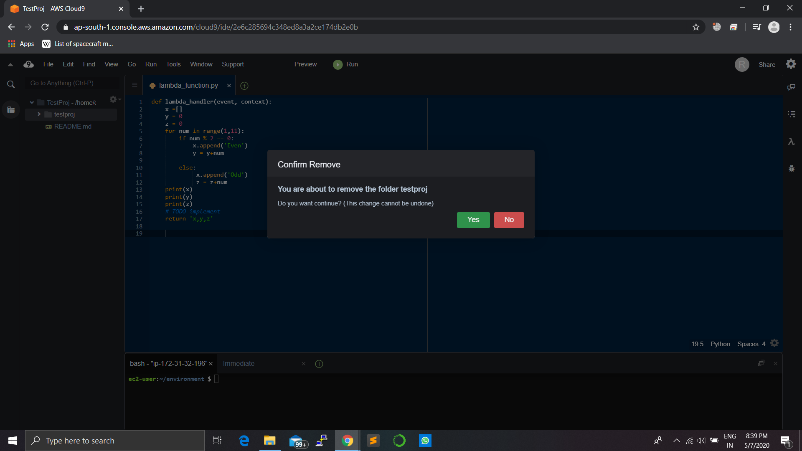

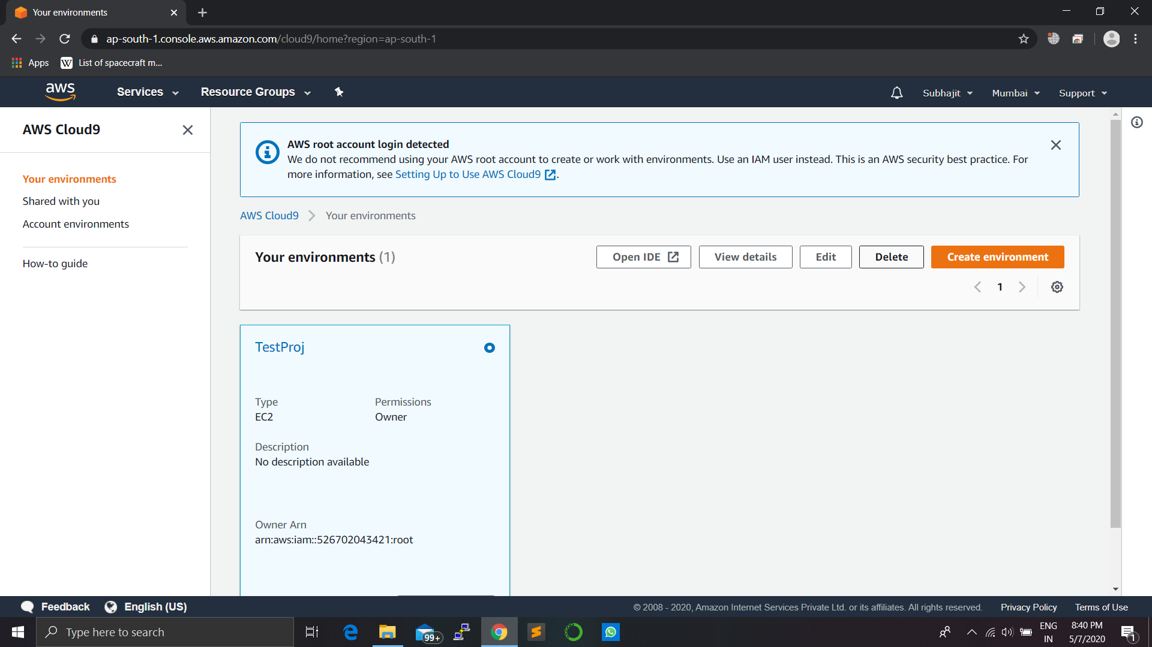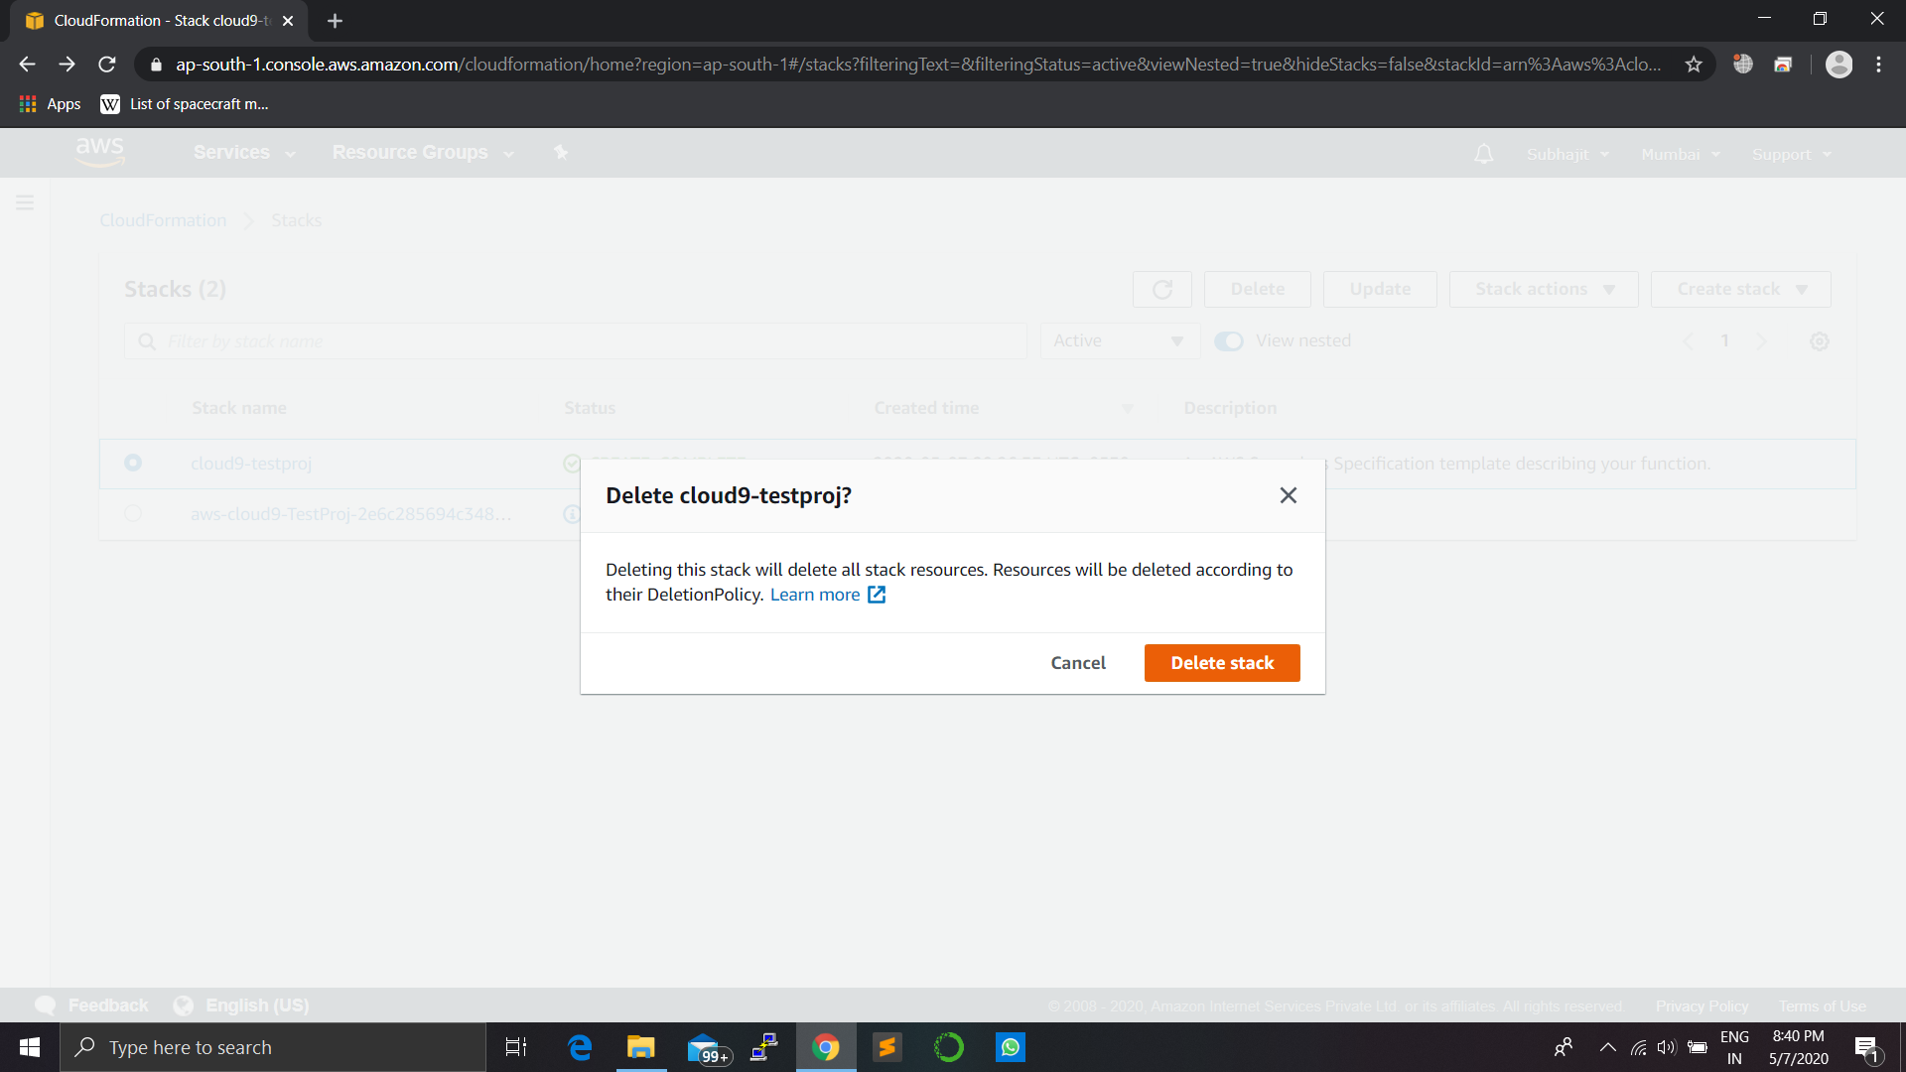

***FINISH***